UML-diagrams

Use-case-diagram

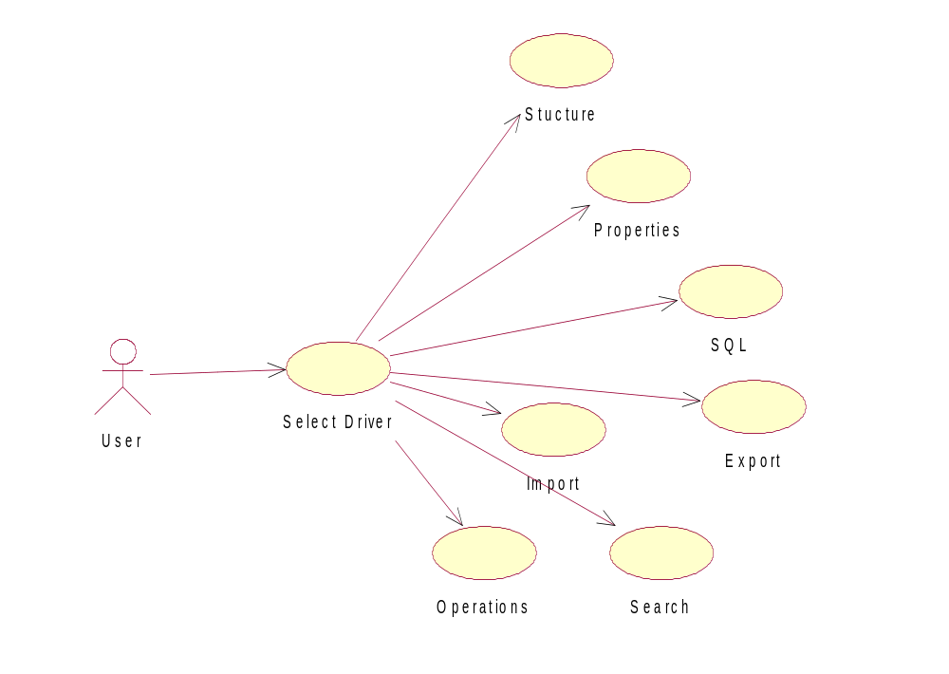

Sequential-diagram

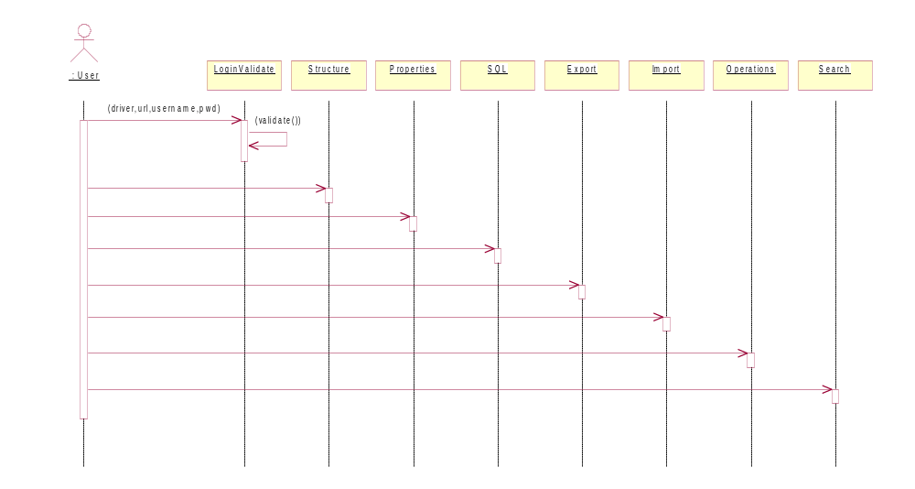

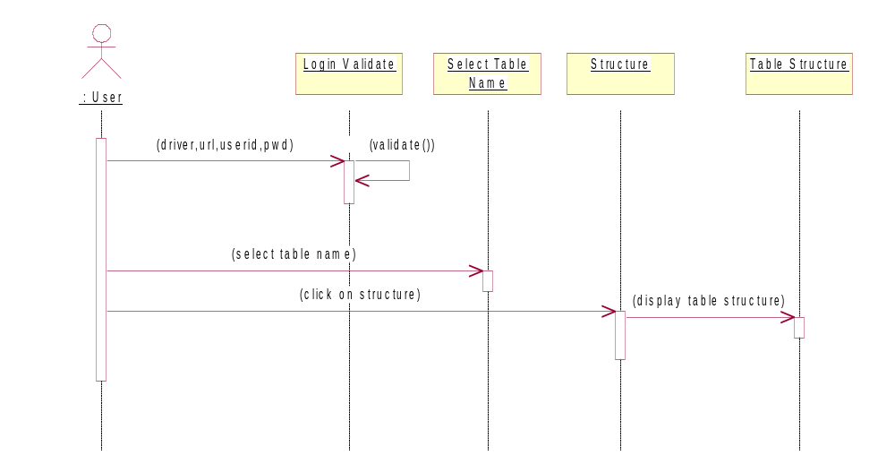

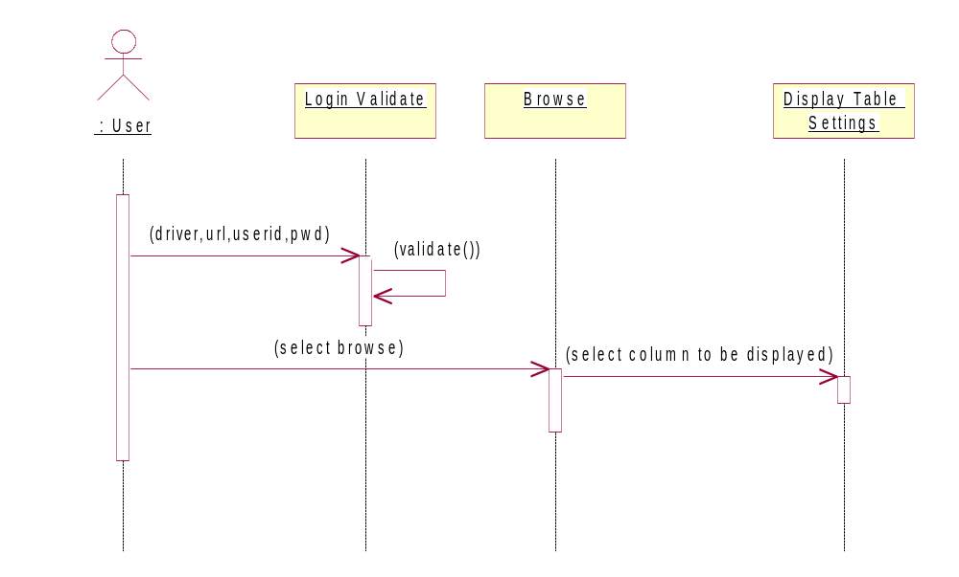

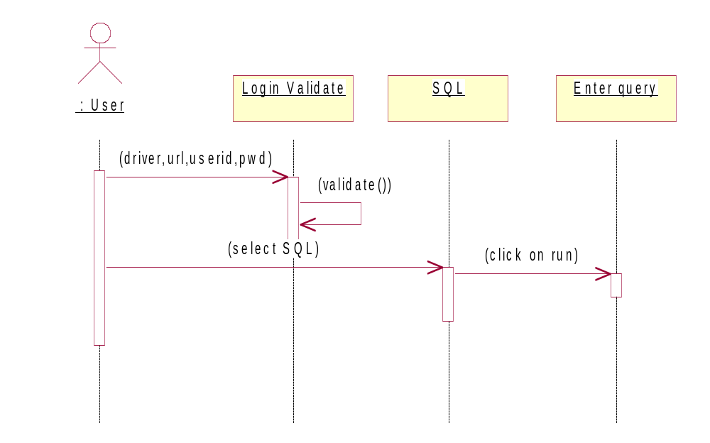

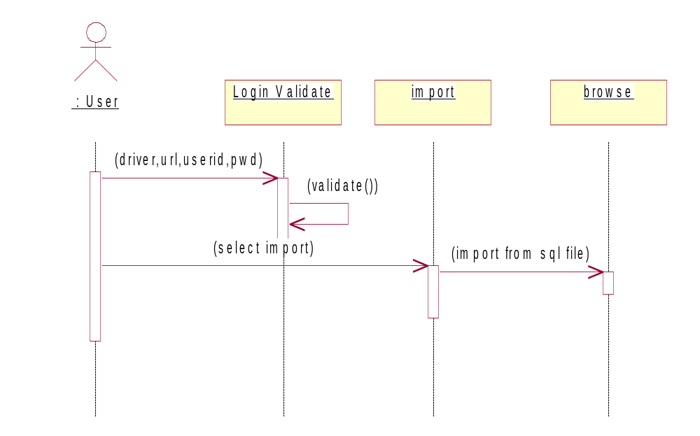
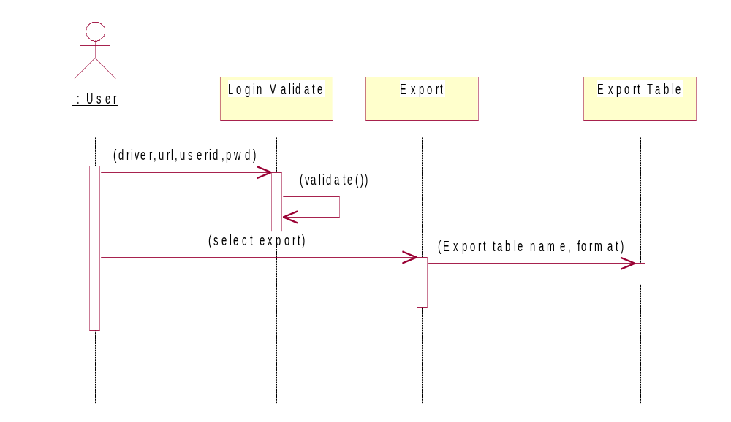

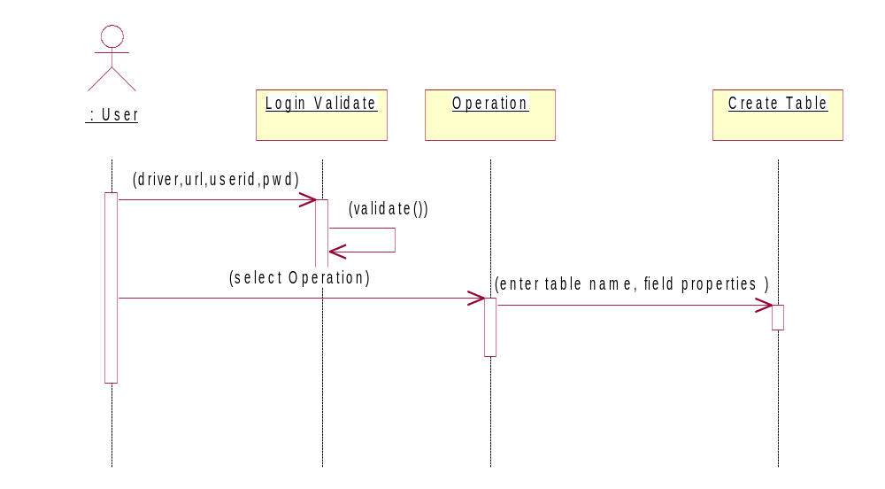

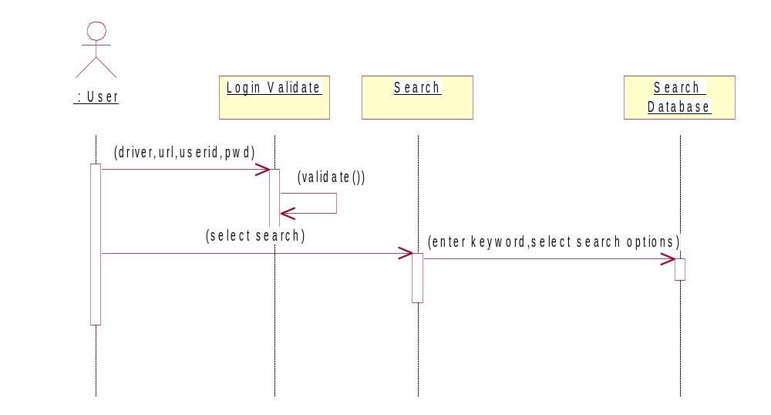

Class –diagram
DataManipulator
Edit Form
Create Tab
Renametab
InputScreen
Report
Menu
GUIComponent
Empty column
DataStore
Desc tab

Browse Form

List DB

<<instantiates>>
<<uses>>
Options
DBOperations

State-diagram

unauthenticated
validation
authenticated
( id,pwd )
( ok )
( id,pwd )

unauthenticated
Validation
DB Menu
( Driver,username,pwd)
( invalid )
( valid )

